WHAT
Module I: Language and Interdisciplinarity
Interdisciplinarity is playing an increasing role in academia, industry and society. The aim of this module is to offer a broad outline to Master students, PhDs and participants interested in a better understanding of possible interdisciplinary approachesin T & I such as cognitive & neurocognitive processes as well as issues related to affective sciences & emotions. Participants will be given a fundamental orientation on those domains with practical applications and will have the opportunity to present & discuss their own projects in a truly multilingual and multicultural environment.
Module II: Language & Cognition
This workshop is designed to Master students interested in brain-behavioural relationship concerningverbal and nonverbal communication in adults. Participants will be familiarized with theoretical and empirical knowledge about the phenomenon of language and cognitive representation as well as with the brain support of language control. Participants will attend input presentations and will be given the opportunity to present and discuss their own projects.
Module III: Language and Artificial Intelligence
Artificial intelligence (AI) is playing an increasing role in the industry and in society. The aim of this module is to introduce to Master students, PhDs and Participants key linguistic elements of AI from a multilingual perspective. They will learn how they can contribute to truly multilingual and multicultural AI applicationsand alsohow AI will help them in their profession.

（To be Continued...）
WHO
Module I:
The theoretical and methodological presentations will be given by Prof. Dr. Hannelore LEE-JAHNKE, A specialist in the field of interdisciplinary training and research.
Prof. Dr. Hannelore LEE-JAHNKE, University of Geneva, President of CIUTI 2009-2012. Honorary Professor of several universities specialized in the training of translators & interpreters
She has done research and published largely within the framework of interdisciplinary translation research and didactics.
Module II:
The seminal theoretical and methodological presentations will be given by Prof Jean-Marie Annoni, expert in the fields of Neurology, language and Cognitive Neurosciences
Prof. Dr. Jean-Marie Annoni is Ordinary professor of Neurology, Department of Medicine, University of Fribourg, and Consultant Neurologist at the Fribourg hospital, university of Lausanne and Geneva).Website: http://www.unifr.ch/neurology/en
Module III:
The theoretical and methodological presentations will be given by Dr. François Massion, an expert from the translation industry in the field of semantic and knowledge technologies.
Dr. François Massion director of DokumentationohneGrenzen, a company specializing in translation and localization services.
He has a teaching assignment in terminology at the Anhalt University of Applied Sciences in Köthen (Germany) and in translation technologies at the German Department of the BFSU University in Beijing.
ä

KEYWORDS

Module I:
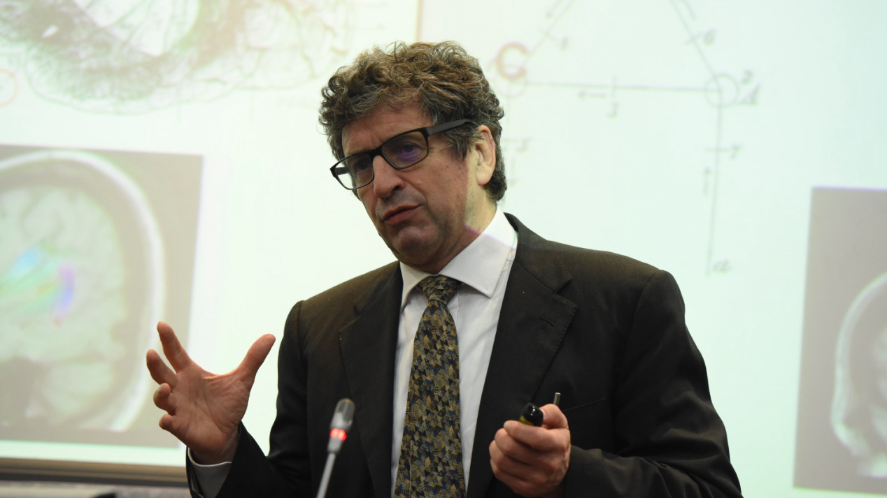
Interdisciplinarity, process-riented research, affective sciences, decision-making, error detection, motivation and cognitive ressources,neurolinguistics, deduction, induction. improvement of learning mechanisms, problem-solving strategies.

Module II:
Cognitive Neurosciences, Language and Brain, Bilingualism, non-invasive neuromodulation of language , Brain Plasticity, Decision Making, Theory of Mind
Module III:
Artificial Intelligence, Natural Language Processing, Frame semantics, Neurolinguistics, Ontologies, Knowledge Management.
（To be Continued...）

 | Module I |  | Module II | Module III | Module IV
9h-9h15 |  | Welcome and introduction
9h15-10h |  | Major trends in interdisciplinary research and training | Neural bases of language | Internet of Things, Artificial Intelligence and languages | New Trends in Geopolitics & Economics
10h-10h45 |  | Neighbouring disciplines of T & I with stress on psycholinguistics & process-oriented studies | Semantic organisation in the brain | Natural Language Processing methods | High-tech developments of China’s economy and translation issues
10h45-11h15 |  | Coffee Break
11h15-12h |  | Affective sciences & practical results in emotion studies | Introduction to the MRI, fMRI and EEG techniques in research | Multilingual knowledge mining: Tools and techniques | Influence on T&I training ; approach to new concepts
12h-12h45 |  | Decision-making process & impact of emotions in error assessment | Language disorders and brain plasticity after brain lesions | Modelling knowledge: Frames and frame-related theories and practice | The Belt & Road initiative  The Two-leaders-theory  Importance of circular economy
12h-14h |  | Lunch
14h-14h45 |  | Motivation as a drive of cognitive resources: Neuroscientific and neurocognitive findings | Definition and Neural bases of pragmatics | Technical languages of the semantic Web: XML, RDF, OWL, SPARQL | A paradigm shift in international leadership: China’s role in restoring faith in Globalization: How does this translate into T&I
14h45-15h25 |  | How to enhance inference capacities through deduction & induction | The Theory of Mind : theory and testing | Making information available: Linked Data, ontoterminologies and ontologies | Module IV/V...
15h25-15h55 |  | Coffee Break
15h55-16h30 |  | Improving learning mechanisms through cognitive activities with stress on reasoning & problem-solving | The bilingual brain | Translation technologies and AI: Current and future developments | Module IV/V...
16h30-17h |  | Perspectives & outlook | Executive functions and Cognitive Control in Bilingual brain | New professional perspectives for Translators and Interpreters | Module IV/V...
End of the day
18h30-18h 30 |  | Multiple choice questions (16 questions)
WHERE
The seminar is offered at the Shanghai International Studies University (Hongkou Campus).
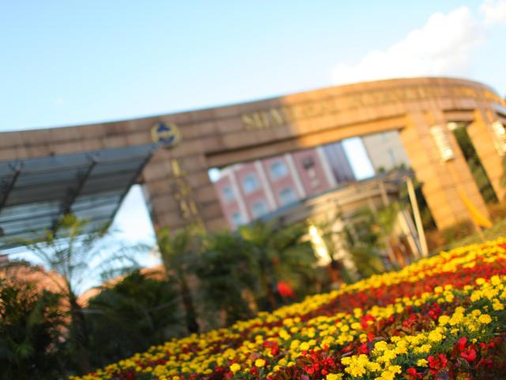

INTERDISCIPLINARY RESEARCH CENTER

GRADUATE INSTITUTE OF TRANSLATION AND INTERPRETATION

SHANGHAI INTERNATIONAL STUDIES UNIVERSITY

REGISTRATION AND CONTACT

Registration Deadline: 15 September 2017.

For registration and more details please visit the website at:
http://giit.shisu.edu.cn/sgic.html

Or write to giitss@shisu.edu.cn.

